P

Project Development Phase

**Sprint - II**

|  |  |
| --- | --- |
| Date | 14 November 2022 |
| Team ID | PNT2022TMID40586 |
| Project Name | Industry-Specific Intelligent Fire Management System |

**LINK:** https://wokwi.com/projects/348658884417684052

# OUTPUT:

**WOKWI OUTPUT**

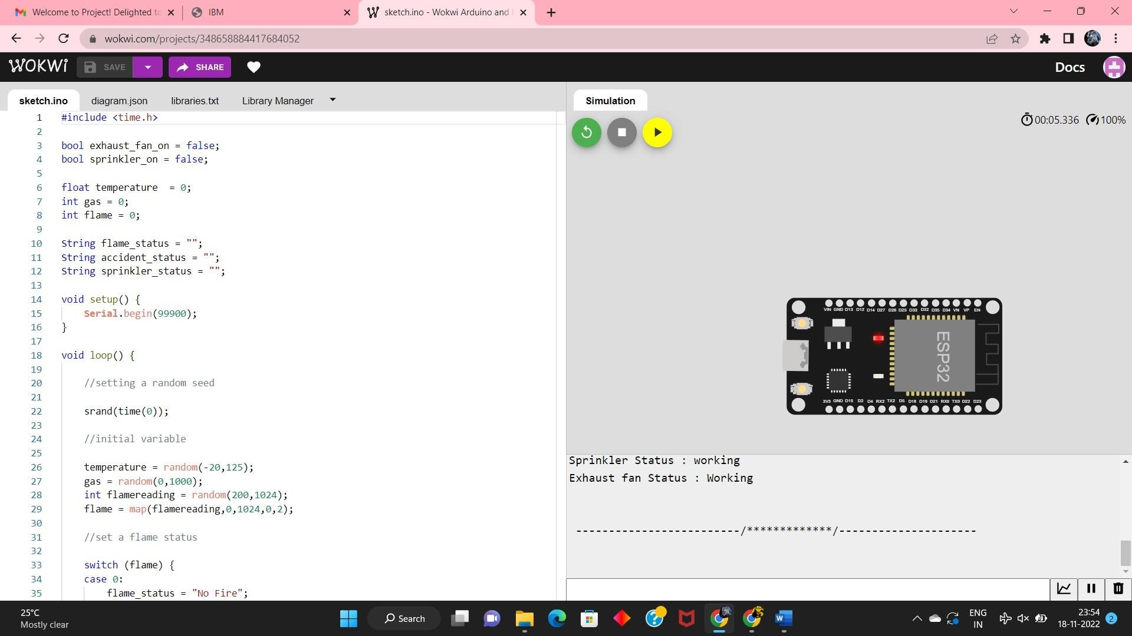

**IBM WATSON OUTPUT**

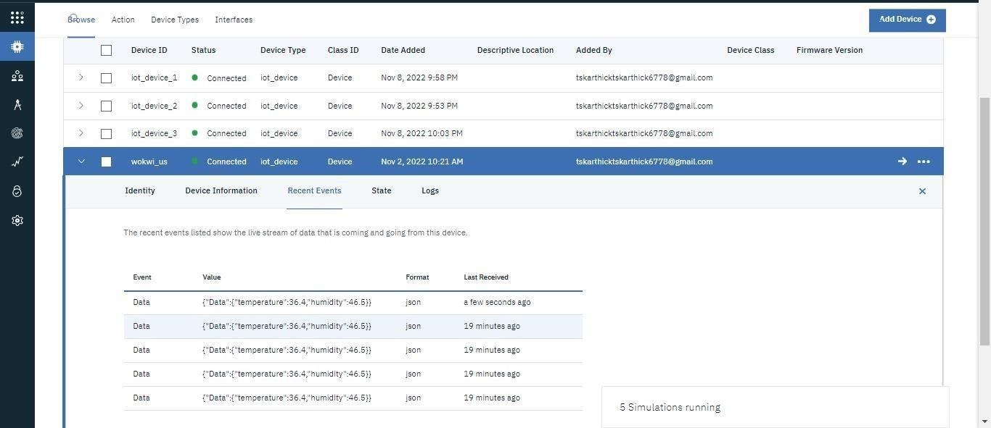

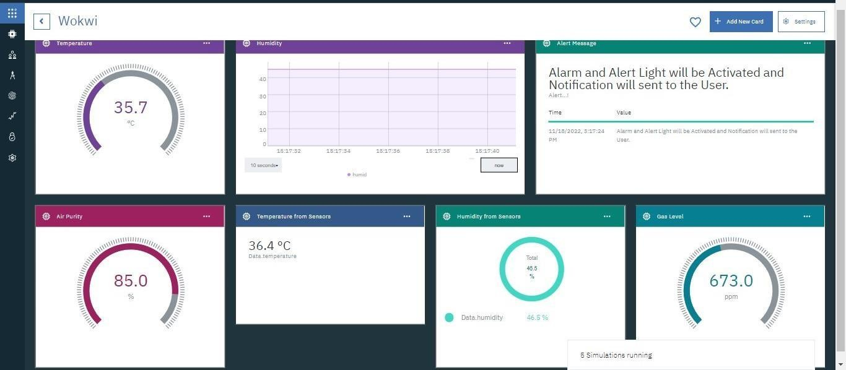**IBM WATSON DASHBOARD OUTPUT**

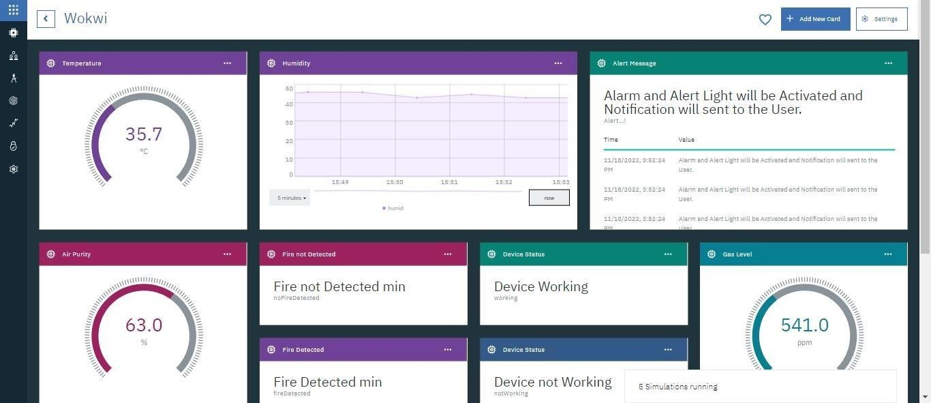

# CODE:

#include <time.h> #include <WiFi.h>

#include <PubSubClient.h>

#define ORG "88653s"

#define DEVICE_TYPE "iot_device"

#define DEVICE_ID "wokwi_us" #define TOKEN ")l(u!YYO)NmKr9sk(k"

char server[] = ORG ".messaging.internetofthings.ibmcloud.com";char publishTopic[] = "iot-2/evt/data/fmt/json"; char authMethod[] = "use-token-auth"; char token[] = TOKEN; char clientId[] = "d:" ORG ":" DEVICE_TYPE ":" DEVICE_ID;

WiFiClient wifiClient;

PubSubClient client(server, 1883, wifiClient);

float temperature = 0; int gas = 0; int flame

= 0;

String flame_status = ""; String Gas_status = "";

String exhaust_fan_status = ""; String sprinkler_status = "";

void setup()

{ Serial.begin(99900);

wifiConnect(); mqttConnect();

}

void loop() { srand(time(0));

//initial variables and random generated data temperature = random(-20,125); gas

= random(0,1000);

int flamereading = random(200,1024); flame

= map(flamereading,200,1024,0,2);

//seta flame status

switch (flame) { case 0: flame_status = "No Fire"; break;

case1: flame_status = "Fire is Detected"; break;

}

//send the sprinkler status if(flame==1){ sprinkler_status = "Working";

} else{

sprinkler_status ="Not Working";

}

//toggle the fan according to gas reading… If (gas > 100){

Gas_status = "Gas Leakage is Detected"; exhaust_fan_status = "Working";

} else{

Gas_status = "No Gas Leakage is Detected";exhaust_fan_status = "Not Working";

}

//json format for IBM Watson

String payload = "{"; payload+="\"gas\":"; payload+=gas;

payload+=","; payload+="\"temperature\":"; payload+=(int)temperature; payload+=","; payload+="\"flame\":"; payload+=flamereading; payload+=","; payload+="\"fire_status\":\""+flame_status+"\","; payload+="\"sprinkler_status\":\""+sprinkler_status+"\","; payload+="\"Gas_status\":\""+Gas_status+"\","; payload+="\"exhaust_fan_status\":\""+exhaust_fan_status+"\"}"; if(client.publish(publishTopic, (char*) payload.c_str()))

{

Serial.println("Publish OK");

} else{

Serial.println("Publish failed");

}

delay(1000);

if (!client.loop())

{ mqttConnect();

}

}

void wifiConnect()

{

Serial.print("Connecting to "); Serial.print("Wifi"); WiFi.begin("Wokwi-GUEST", "", 6);

while (WiFi.status() != WL_CONNECTED)

{

delay(500); Serial.print(".");

}

Serial.print("WiFi connected, IP address: "); Serial.println(WiFi.localIP());

}

void mqttConnect()

{ if

(!client.connected())

{

Serial.print("Reconnecting MQTT client to "); Serial.println(server); while (!client.connect(clientId, authMethod, token))

{

Serial.print("."); delay(500);

}

Serial.println();

}

}

## LOGIN PAGE OUTPUT:

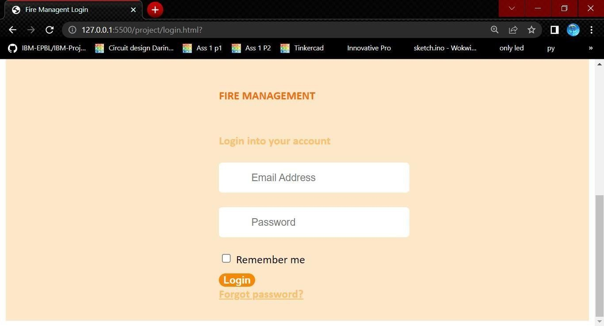

**RESET PAGE OUTPUT:**

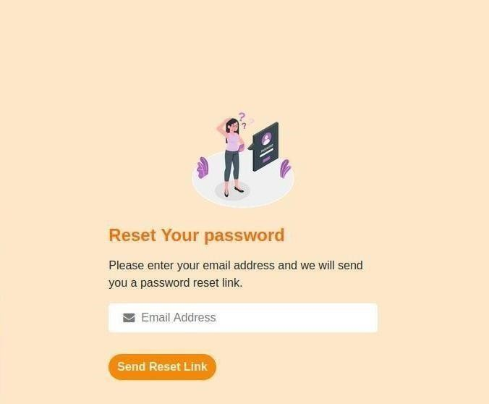

## LOGIN CODE:

<!DOCTYPE html>

<html>

<head>

<title>Login</title>

<meta charset="utf-8">

<meta name="viewport" content="width=device-width, initial-scale=1, shrink-to-fit=no">

<link href="style.css" rel="stylesheet" type="text/css">

<link rel="stylesheet" href="https://stackpath.bootstrapcdn.com/bootstrap/4.5.0/css/bootstrap.min.css">

<link href="https://stackpath.bootstrapcdn.com/font-awesome/4.7.0/css/font-awesome.min.css" rel="stylesheet"> <script src="https://code.jquery.com/jquery-3.5.1.slim.min.js"></script>

</head>

<body>

<div class="container-fluid">

<div class="row ">

<!-- IMAGE CONTAINER BEGIN -->

<div class="col-lg-6 col-md-6 d-none d-md-block infinity-image-container"></div>

<!-- IMAGE CONTAINER END -->

<!-- FORM CONTAINER BEGIN -->

<div class="col-lg-6 col-md-6 infinity-form-container">

<!-- <h4 class = "test" style="color:#fa6903;">FIRE MANAGEMENT</h4> -->

<div class="col-lg-9 col-md-12 col-sm-9 col-xs-12 infinity-form">

<!-- Company Logo -->

<div class="text-center mb-3 mt-5">

<h4 class = "test" style="color:#fa6903;">FIRE MANAGEMENT</h4>

</div>

<div class="text-center mb-4">

<h4>Login into your account</h4>

</div>

<!-- Form -->

<form class="px-3">

<!-- Input Box -->

<div class="form-input">

<span><i class="fa fa-envelope-o"></i></span>

<input type="email" name="" placeholder="Email Address" tabindex="10"required>

</div>

<div class="form-input">

<span><i class="fa fa-lock"></i></span>

<input type="password" name="" placeholder="Password" required>

</div>

<div class="row mb-3">

<!-- Remember Checkbox -->

<div class="col-auto d-flex align-items-center">

<div class="custom-control custom-checkbox">

<input type="checkbox" class="custom-control-input" id="cb1">

<label class="custom-control-label text-black" for="cb1" style = >Remember me</label>

</div>

</div>

</div>

<!-- Login Button -->

<div class="mb-3">

<button type="submit" class="btn btn-block">Login</button>

</div>

<div class="text-right ">

<a href="reset.html" class="forget-link">Forgot password?</a>

</div>

</div>

</div>

</form>

</div>

</body>

</html>

</div>

<!-- FORM CONTAINER END -->

## RESET CODE:

<!DOCTYPE html>

<html>

<head>

<title>Reset</title>

<meta charset="utf-8">

<meta name="viewport" content="width=device-width, initial-scale=1, shrink-to-fit=no">

<link href="style.css" rel="stylesheet" type="text/css">

<link rel="stylesheet" href="https://stackpath.bootstrapcdn.com/bootstrap/4.5.0/css/bootstrap.min.css">

<link href="https://stackpath.bootstrapcdn.com/font-awesome/4.7.0/css/font-awesome.min.css" rel="stylesheet"> <script src="https://code.jquery.com/jquery- 3.5.1.slim.min.js"></script>

</head>

<body>

<div class="container-fluid">

<div class="row">

<!-- IMAGE CONTAINER BEGIN -->

<div class="col-lg-6 col-md-6 d-none d-md-block infinity-image-container"></div>

<!-- IMAGE CONTAINER END -->

<!-- FORM CONTAINER BEGIN -->

<div class="col-lg-6 col-md-6 infinity-form-container">

<div class="col-lg-8 col-md-12 col-sm-8 col-xs-12 infinity-form">

<div class="text-center mb-3 mt-5">

<img src="ps.webp" width="150px">

</div>

<div class="reset-form d-block">

<form class="reset-password-form px-3">

<h4 class="mb-3" style="color:#fa6903">Reset Your password</h4>

<p class="mb-3 text-black">

Please enter your email address and we will send you a password reset link.

</p>

<div class="form-input">

<div class="mb-3">

</form>

</div>

</div>

</div>

<span><i class="fa fa-envelope"></i></span>

<input type="email" name="" placeholder="Email Address" tabindex="10"required>

<button type="submit" class="btn" >Send Reset Link</button>

<div class="reset-confirmation d-none px-3">

<div class="mb-4">

<h4 class="mb-3">Link was sent</h4>

<h6 class="text-white">Please, check your inbox for a password reset link.</h6>

</div>

<a href="login.html">

<button type="submit" class="btn">Login Now</button>

</a>

</div>

</div>

<div>

</div>

</div>

<!-- FORM CONTAINER END -->

<script type="text/javascript"> function PasswordReset() {

$('form.reset-password-form').on('submit', function(e) { e.preventDefault(); $('.reset-form')

.removeClass('d-block')

.addClass('d-none');

$('.reset-confirmation').addClass('d-block');

});

}

window.addEventListener('load', function() { PasswordReset();

}); </script>

</body>

</html>

## STYLE CODE:

.container-fluid{ background- color: black; }

.infinity-image-container{ background: url('fire.jpg') center no-repeat; background- size: cover;

height: 100vh;

}

.infinity-form-container{ background: #fce7c9; display: flex; flex-direction: column;

align-items: center; justify-content: center;

}

.infinity-form{ display: flex; flex-direction: column; justify- content: center; min- height: 100vh; }

.infinity-form h4 { font- weight: bold; color: #ffbe6a;

font-weight:

bol;

}

.infinity-form .form-input { position: relative; }

.infinity-form .form-input input { width: 100%; margin- bottom: 20px; height: 40px; border: none; border-radius: 5px;

outline: none; background:

white;

padding-left: 45px;

}

.infinity-form .form-input span { position: absolute; top: 8px; padding-

left: 20px; color:

#777;

}

.infinity-form .form-input input:focus, .infinity-form

.form-input input:valid { border: 2px solid #fbae4e; }

.infinity-form input[type="checkbox"]:not(:checked) + label:before{ background: transparent; border:2px solid #ffbe6a; font- weight: bol; width: 15px;

height: 15px;

}

.infinity-form .custom-checkbox .custom-control-input:checked ~ .custom-control-label::before { background-color: #feb449 !important; border:0px;

}

.infinity-form button[type="submit"] { margin-top: 10px; border: none; cursor: pointer; border-radius:

20px; background: linear-gradient(45deg, #f88702,#f88702); /*Button Color*/color:

#ffFF; font-weight: bol; font-weight: bold; transition: 0.5s;

}

.infinity-form button[type="submit"]:hover { background: linear-gradient(45deg, #FEB449, #feb449); /*Button color when hover*/

}

.forget-link , .login-link , .register-link { color: #ffbe6a; font-weight: bold;

}

.forget-link:hover , .login-link:hover , .register-link:hover { color: #feb449; text-decoration: none;

}